Appendix I

Bandwidth Management

With the high cost of bandwidth and the number of applications who share a single link, there becomes a need to manage the traffic going into and out of a network. Within the LearnCanada project, the required bandwidth each site requested from their local ISP was approximately 6 to 10 Mbps. This link however was shared between a number of applications like, the ISABEL application, FTP server, Web access, and video annotation server.

For the bandwidth management portion of the project, CRC looked at ways to control, divide and manage the traffic in a shared network link.

For this, CRC used a product from Xedia (now Lucent) called the AP100. The AP100 is a bandwidth management tool, which allows the user to control the amount of traffic depending on the packet type, originating source or destination source.

Test plan:

The purpose of this test is to simulate a network environment where various users running various applications are sharing a network link to the Internet. When user applications compete for traffic, there is no guarantee that one application will get the necessary bandwidth it needs. When one application requires a guaranteed amount of bandwidth, the shared network link must be managed, giving priority to one application over another. Or by taking the link and divided the link up for various application. For this test we will be taking a 10 Mbps network connection and managing the traffic by subdividing the 10 Mbps link into 3 sections.

For the management of bandwidth, it will be accomplished using the AP100 by Xedia (now Lucent). The following diagram depicts the network setup for this particular test.

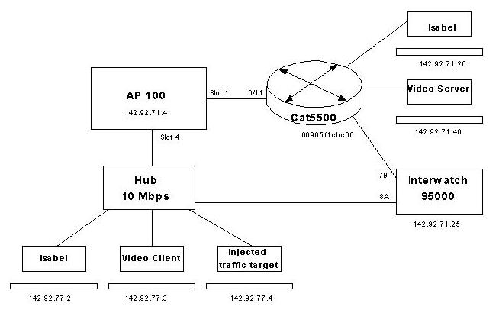

Results:

Originally, without the AP100 in the network, i.e. the 10Mbps Hub connects directly to Cat 5500. An ISABEL session or a video streaming session, running at approximately 1.5Mbps, was interrupted when the Interwatch injected 7.6 Mbps of best effort traffic. With the AP100 in the network, as shown in the diagram above, the ISABEL session or video streaming session will continue to run no matter how big the best effort traffic is injected into the network.

During the test, a problem with the software release (ie; version 2.1) was found. This release was unable to classify fragmented frames. Was only able to see 10% of video streaming or ISABEL traffic on the AP100 graphical equalizer. Upgrade to version 2.5 will cost $1000US and which fixed the fragmented frame issues. Lucent took over Xedia and developed a new product called AP300 cost $5000US

