Appendix G

Linux/ISABEL Training Material

The primary Operating System (OS) which was used for the project was Linux, specifically Redhat. The applications used for the project ran mostly on Linux. Throughout the project, basic training was given to the technical staff and teachers on the installation, setup, and use of Linux Redhat and ISABEL. This section covers the training materials used for the various training sessions. Within each of these sections include Frequently Asked Questions (FAQs) which arose throughout the project.

(1) LINUX

This following describes the Redhat Linux Operating System.

Setup and basic operations:

The installation of Linux was given to the Technical Staff during the kickoff meeting of the LearnCanada Project at CRC. The training covered a step by step walk through of the installation process from disk partitioning, network settings, to Xserver configurations. Problems or issues, which commonly arise were covered. See training material.

There were significant improvements with the ISABEL audio, which resulted in the application moving from using OSS audio drivers to the Advanced Linux Sound Architecture (ALSA) drivers. Some of the latter versions of ISABEL required ALSA drivers to be installed before installing ISABEL. Dependency errors will occur if ALSA was not properly installed. Installation of the ALSA drivers was a task, which did not go smoothly for a number of sites.

The most common problem when installing the ALSA was sites did not enter any or the correct paths during the configuration stage. The following options should be included when configuring ALSA drivers.

./configure --with-kernel=/usr/src/linux-2.x.x-x/ --with-moddir=/lib/modules/2.x.x-x/misc --with-cards=<card-name>;make;make install

Once the installation of Linux, ALSA, and ISABEL are completed, the next set would be to secure the Linux box before plugging it onto the network. For this, see "Appendix H: Steps for securing Linux".

FAQs:

Question: Monitor resolution was too low or too high?
Monitor not syncing to projector?
Answer: In either cae, you can use Xconfigurator and re-configure the X setting and choose 1024x768.
Or, you can edit the /etc/X11/XF86Config-4 file (for users running XFree86 versions < 4.0, you will need to edit the /etc/X11/XF86Config file) and change the Modes under "Section "Screen""

Section "Screen"
Identifier "Screen0"
Device "VESA driver"
Monitor "Monitor0"
Subsection "Display"
Depth 16
Modes "1024x768"
Endsubsection
Endsection

Question: Local loop problem with video within ISABEL.
Answer: This is a problem when running ISABEL, however, it is a Linux issue.
During the installation, you may notice that the /etc/host file will look as
follows:

127.0.0.1 kappa kappa.badlab.crc.ca localhost.localdomain localhost

You must change the file as follows:

127.0.0.1 localhost.localdomain localhost
xx.xx.xx.xx kappa.badlab.crc.ca kappa

Question: Cannot see anything past the local network interface.
Answer: This problem was usually due to no default route set. To set the default route, run the following bash command:

"route add default gw xx.xx.xx.xx dev eth0"

Question: Having problems configuring ALSA. Keep getting errors.
Answer: Depending on the error which occurred during the installation process, run the ./configure command with the following option.

./configure --with-kernel=/usr/src/linux-2.x.x-x/ --with-moddir=/lib/modules/2.x.x-x/misc --with-cards=<card-name>;make;make install

(2) ISABEL

Setup:

The ISABEL application is packaged into a RPM file for quick and easy installation. As long as all the dependencies are installed, the ISABEL installation should not complain.

When you first install ISABEL, there are many default parameters set, which we want to change. Some of the changes are as follows:

- Enable audio tones in the audio mixer.

To change this, you will need to start a terminal window, and login as root. Change directory to /usr/local/isabel/lib/act/conference/. There you will find a file called conference. Run a “more conference”. Scroll down till you reach the audio section. Edit this file and change all the “audioCtrl” to just “Ctrl”.

- Change PAL to NTSC

By default PAL is set as the video source under the $HOME/.isabel/config/v4l.conf file. The “vnorm” setting must be changed from 0 to 1.

- Video Source

If you are running composite as your video camera input, then you will not need to make this change. In your $HOME/.bash_profile, add the following lines:

$V4L_CHANNEL=2
export V4L_CHANNEL

This will set the source to s-video.

(iv)

Operations:

With the latter versions of the applications, starting ISABEL can be done through the Web Portal or as a stand alone. As indicated in Appendix E, sites can join an advertised session by simply joining and entering their login names.

However, to start a session without the Web Portal is a little more complex. The following section describes the steps to configure ISABEL as either a master site or a participating site without the portal.

Starting ISABEL without the Web Portal

The startup for ISABEL has changed quite a bit from previous versions:

Here is a quick guide to setting up an ISABEL session without going through the Web Browser.

For the setup, start your "isabel" at the terminal command prompt. This will bring up the Isabel with the "Welcome to Isabel Launcher Page"

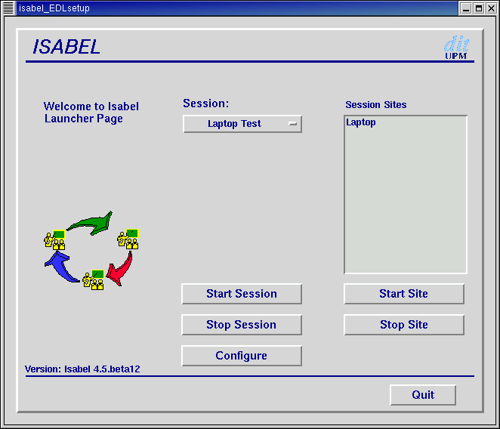

To configure as the master:

- Go to Configure and this will bring up the "Event configuration" page.

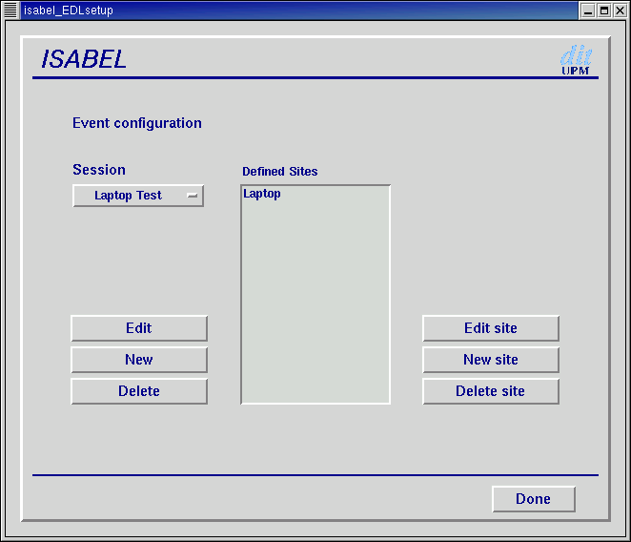

- Select New and the "Session data" data page will appear.
Session name = CRC-P2P
NO Password
Service = Telemeeting
Session Identifier = 32000
Master = CRC
Open session = yes
Retransmit to watchpoint = doesn't matter
Sites: click add, and enter CRC
- Once all entered, select next and select the Bandwidth selection to 2000 Kbps. Hit next (no additional parameters) and then finish.

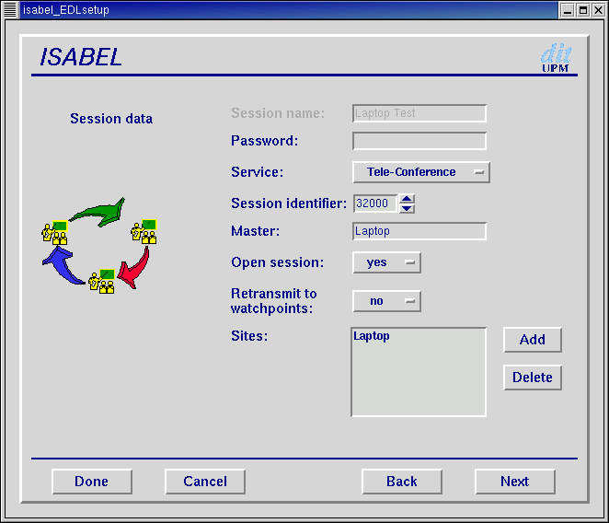

Now you should be back at the "Event Configuration" page.

- Select New Site
Name = CRC
Public = Communications Research Centre
Site address = your machines IP address of your ethernet card.
- Next, and select interactive terminal (the first option)
- Next, "Connection access" page, select Ethernet
- Next, "Connection mode" page.
- Select Flow concentration station
- Upload BW = 2000
- Download BW = 2000
- Connect to flowserver = IP addresses of a separate flowserver or leave blank.
- Next, "Media Controls" page. If you do not want to export the control windows to another display then leave this blank.
- Next, "Site additional parameters" page.
- Nothing to add here.
- Finish
- Done
- Back to the Welcome page. Start Session

To configure as an interactive site:

Pretty much the same.

- Go to Configure and this will bring up the "Event configuration" page.
- Select New and the "Session data" data page will appear.
Session name = CRC-P2P
NO Password
Service = Telemeeting
Session Identifier = 32000
Master = IP address of the master site
Open session = yes
Retransmit to watchpoint = doesn't matter
Sites: click add, and enter CRC
- Once all entered, select next and select the Bandwidth selection to 2000 Kbps. Hit next (no additional parameters) and then finish.

*PLEASE NOTE: Where you entered CRC in bold above, this must match the Name = CRC in bold below.

Now you should be back at the "Event Configuration" page.

- Select New Site
Name = CRC
Public = Communications Research Centre
Site address = your machines IP address of your ethernet card.
- Next, and select interactive terminal (the first option)
- Next, "Connection access" page, select Ethernet
- Next, "Connection mode" page.
- Select Flow concentration station
- Upload BW = 2000
- Download BW = 2000
- Connect to flowserver = IP address of the master site which you entered above
- Next, "Media Controls" page. If you do not want to export the control windows to another display then leave this blank.
- Next, "Site additional parameters" page.
- Nothing to add here.
- Finish
- Done
- Back to the Welcome page. Start Session

For a manual on using the ISABEL features and tools, please go to http://isabel.dit.upm.es and select “downloads, documents” and there you will find a link for the ISABEL Reference Manuals.
FAQs:

The FAQs were from both the technical staff and from the teachers on how to start, run, and operate ISABEL.

Question: No video being displayed. See only a blue screen.
Answer: Check to see if there is a camera source plugged in. If the camera is
plugged in, check to see if the ISABEL video is set to s-video or composite. To check this, you go to the control and select the camera.



A window will appear as follows

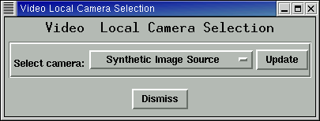

Make sure the camera selection is correct. Default usually is Synthetic Image Source or Composite.

Question: No Audio from other sites. No audio from local.
Answer: If there is no audio from the other sites, make sure the output slider on the
ISABEL audio mixer is enabled. By default, the mixer will set the output to disable. If there is not audio from the local site, ensure that the audio input is correctly set.

Question: Slides are not being displays.
Answer: First, make sure that the presenter of the slides sent out the slides to all sites. If slides were sent and you still do not see the slides, run "nautilus" at the command prompt. The following window will appear.

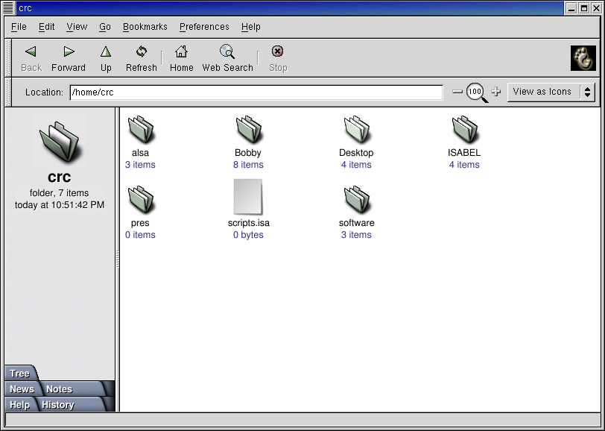

Go to "Preferences" and then select "Edit Preferences".

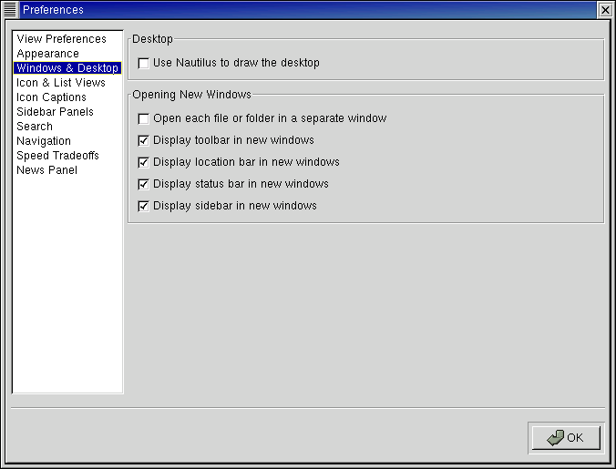

Select "Windows & Desktop" and disable "Use Nautilus to draw the desktop". Once this is done, refresh the slide component of ISABEL and the slides should appear.

Question: Video is coming out either compressed or colours are not correct.
Answer: By default, the ISABEL application sets the camera options to PAL. The v4l.conf file must be changed to NTSC. The v4l.conf file is located in $HOME/.isabel/config directory. The "vnorm" option must be changed from 0 to 1. Once the change is made, you can either restart the ISABEL application, or from the partners menu and kill and then restart the video component for the troubled site.

Question: Everytime I try and start a session from the Web Portal, it keeps asking me to “save as” and no login prompt appears.
Answer: Make sure you are running Netscape version 4.5-x or higher.
Insure that you correctly configured Netscape correctly.

To configure the browser, go to

Edit -> Preference -> Applications

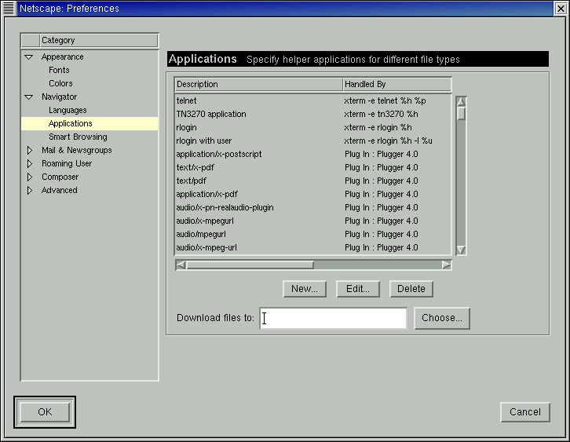

Select NEW and add the following parameters:

Description: Isabel Web Service
MIMEType: application/risabel
Suffixes: .isa

Note: make sure you enable the "Use this MIME as the outgoing default for these extensions."

Select the applications and enter the following:

/usr/local/isabel/bin/isabel -edlconf %s

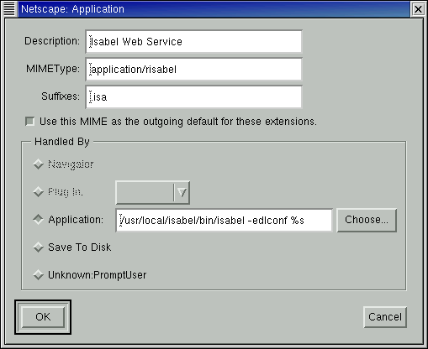

Go to Advanced, Cache, and select “Document in Cache is compared to document on network” to Every time.

Training material used for the kickoff meeting.

See the attached files

Installing-ISABEL.ppt
Isabel-application.ppt
Isabel-HW-SW-requirements.ppt
Linux-Redhat6.2-install.ppt

