Appendix F

Streaming Video

Video streaming for the LearnCanada project was done using H.263 video and MPEG-2 video. The following section will discuss both video streaming options used in the project. The first being H.263 video streaming. H.263 is an International Telecommunications Union (ITU) standard, which supports video encoding for video conferencing applications. The second is MPEG-I/II video streaming.

(i) H.263 Video Streaming:

The H.263 video streaming was achieved using the H.323 Polycom FX system. The FX was equipped with software enabling H.263 video streaming. An ISABEL station with a video card equipped with a TV output was connected to a Polycom station. This allowed remote users to join the session as a passive participate, similar to the ISABEL watchpoint.

To join the session, viewers would run from either a web browser or Windows media player entering the address of the Polycom.

(ii) MPEG-I/II video streaming:

The product purchased to stream MPEG video is from Optibase called the MGW2000 video server. This server is capable of encoding and transmitting up to a maximum of 6 live videos and 10 stored videos at once. Management of the server is done through the web interface.

Server:

For the LearnCanada Project, the MGW2000 was equipped with the MGE-200D MPEG-I/II encoder module. This modules is capable of encoding MPEG-I SIF, MPEG-1 QSIF, MPEG-2 Half D-1, MPEG-2 Full D-1. Video resolution and target bit rates range from QSIF and SIF @ 170 Kbps to 5 Mbps, and HD1 and FD1 @ 2 Mbps to 15 Mbps.

Various audio encoding modes can be chosen, from stereo, mono, intensity stereo, or dual mono. Audio bit rates range from 32 to 384 Kbps.

The following diagram depicts the setup for the Optibase MPEG video server.

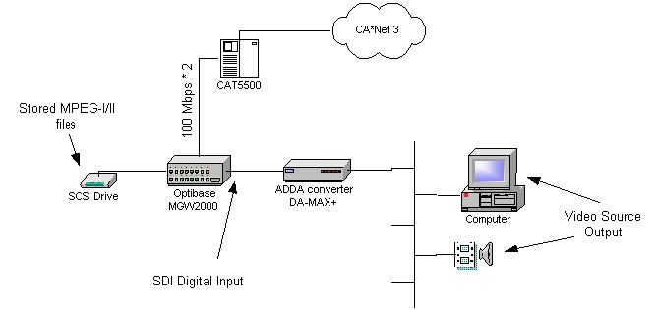

Connected to this device is an external 160 GB SCSI drive used for storing MPEG files for later playback.

Clients:

Currently the decoding of the MPEG videos are done using Optibase products. MPEG-1 streams are decoded on the client using Optibase's Commotion Receiver software. The Commotion software uses the Windows Media player as the player. Decoding MPEG-2 streams are done using hardware decoder cards. Optibase Video Plex PCI decoder cards are currently required to decoded MPEG-2 streams.

Alternative MPEG-11 Client Options:

OptiBase has been working with a company called Elecard. Elecard is a Russia based company working on MPEG-II software codecs. Currently Elecard has released a version of the MPEG-II player capable of decoded MPEG-II video through software. A third party has developed a filter to decode the OptiBase MGW2000 MPEG-II video streams using the Elecard MPEG-II player. Currently the software based solution is not yet fully functional. Still runs best with the OptiBase Videoplex hardware decoder.

