Appendix D

(i) Introduction

The X-Bone is a system for the rapid, automated deployment and management of overlay networks, supporting concurrent experiments on shared research infrastructure. Overlay networks use encapsulation to enable virtual infrastructure, and they are being used more frequently to implement experimental networks and dedicated subnets over the Internet. Existing overlays, such as the M-Bone for multicast IP, require manual configuration and management, both to establish connectivity and to ensure efficient resource utilization. The X-Bone automates the deployment of overlays, using a graphical interface and multipoint control channel to manage overlay deployment at the IP layer, using existing protocols and operating systems interfaces in new ways.
The X-Bone system uses a multicast invitation mechanism to simplify resource discovery. The system addresses infrastructure sharing in phases, incorporating new mechanisms and protocols, such as in-band tunnel management, as they are developed. The X-Bone front-end consists of a web-based graphical control interface (GUI), and an automated back-end Overlay Manager (OM), to manage the initial deployment and coordinate the components thereafter. Control to the OM is provided to programs via an API. The OM is a centralized deployment manager. The X-Bone back-end is called a Resource Daemon, and runs on each shared component (host or router). Resource Daemons include a registry to coordinate resource utilization and other shared state. Daemons on each node translate configuration commands into device-specific control.
The purpose of this project is to implement X-Bone network and to test Isabel application over this network. Afterward, we need to find the way to improve the performance of Isabel. Once arrival at this state, we would like to extend X-Bone throughout all the CA*Net3 (next-generation Internet Backbone in Canada) to create a Virtual Private Network (VPN) between each LearnCanada sites.

(ii) Implementation and configuration the X-Bone Network

In this section, first we explain all the process of X-Bone implementation, from the creation of Certificate Authority to the installation of X-Bone Daemon. Every step is presented in details preceded by an overview of the theory. Secondly, we describe the Overlay manager GUI for the user configuration. Also we project to improve performance in the Isabel application base on the assumption that we can limit the throughput going to certain site and give priorities to certain types of packets.

Introduction to Internet Privacy

Brief Overview of PKI

PKI stands for Public Key Infrastructures it is a cryptographic method that is asymmetric. That means that each end has it's own set of keys instead of sharing the same one. To be more precise we will start by explaining the traditional style of cryptography called symmetric or shared key cryptography.
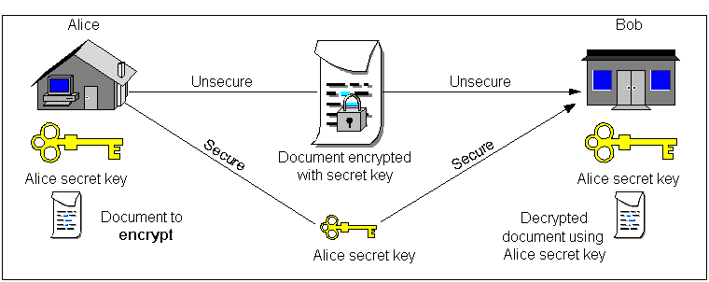

Figure of shared key cryptography.

The shared key cryptography is the most common type of cryptography. It consists of creating a key with which we can encrypt a message. The same key is used for decryption so each party involved in the exchange of the message must have the key. This is a security flaw because, if the key is acquired by an unwanted third party (that is more likely to occur since many sites have the same key), all messages from all participating sites encrypted using this same key are now compromised. Figure following illustrates how shared or common key cryptography works.

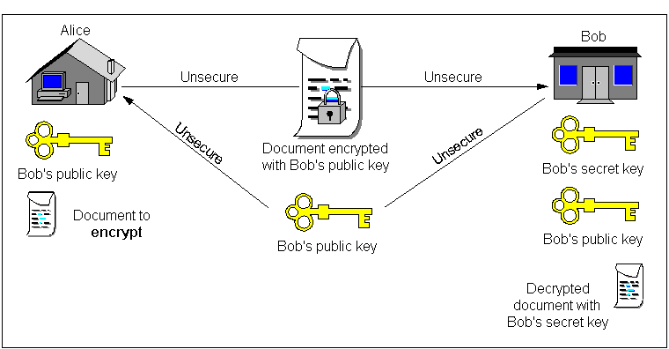
Figure of public key cryptography.

The public key cryptography is asymmetric because we cannot encrypt and decrypt using the same key. Indeed this method of encryption consists of having two keys (one called public and the other private). The concept is quite simple. We encrypt using the receiver's public key and the receiver can decrypt it using his private key. This way the receiver only has to give you his public key and can keep his private key safe. For example, let's say that Alice wants to send an encrypted message to Bob. Alice needs to ask Bob to give his public key then she can encrypt her message with his public key so that he is the only one who can decrypt it because he has his private key.
The public key extends its use to things called digital signatures and certificates. Indeed, it's a good thing to be able to encrypt using a public key and to decrypt using the private key but, how can you tell if the message has not been modified? . That is why a thing called message digest is included in the message. The digest is a summary of the message created at the source computer and recreated at the destination computer; if the two of them match then the message has not been modified. For example, if Bob wants to make sure that what Alice wrote was accurate, then he needs to see if his message digest is the same as the one included in the message. But that doesn't really confirm that the message is really from Alice, it only confirms that it was unchanged after encryption. That is why there is such a thing called non-repudiation. This is to authenticate that the source of the message is really from whom he or she claims to be. In order to do that, certificates were implemented. A certificate is a public key signed by a trusted third party, called certificate authority (CA). The certificate is signed with the CA's private key in such a way that anyone that has the CA public key can verify the authenticity of the certificate.
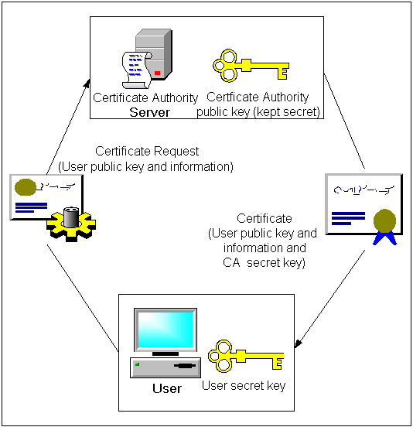

Figure of Certificates and Digital Signatures.

Creating the certificates

Creating a Certificate Authority

We need to have a Linux machine with OpenSSL installed. The following steps were done using OpenSSL 9.5a so we recommend installing the source code version since you will need it in the recompilation of Apache later. We also need to install the CA.pl script that codes with the source code package of OpenSSL and that is located in the apps/ subdirectory. Since CA.pl is a perl script you need to have it installed. If it's not yet you can do it now (See PERL source README).

Creating the CA key and certificate

These are the steps one must undertake in order to create a new CA key and certificate.

Open the openssl.cnf file (it should be located under /usr/share/ssl/ or use locate to find it)
Edit the file to specify where you want the CA directory created.
Type "openssl -newca"
You’re asking for some information, you can type in any information you want but you have to be sure to remember the password (write it down on a piece of paper) because you will always need it when signing certificates.
This creates a file called $yourcadir/cacert.pem and a file $yourcadir/private/cakey.pem be sure that the key is safe and secure but you can redistribute cacert.pem to anyone under your certificate authority (In this case you have to give it to every X-Bone hosts. Users have to download it).
You now own your own Certificate Authority and you are ready to create host keys and certificates.

Creating the Host key and certificate

There are multiple methods you can take in creating the host key and certificate. The first one is to create the key and the signed certificate on the CA machine itself and then give them to each hosts via secure FTP (sftp) or hand-to-hand floppy disk. The other way, which is recommended because it is more secure is to have your host create his key on his machine, then have him issue you a certificate request then you can sign it on your CA computer and give him the signed certificate back. We will outline the two methods in the following texts. We will refer computers as Alice and Bob.

Method 1 - Less secure but easier way

If security is not of primordial importance you can do the following.

First create a key for your host by typing "openssl genrsa -out hostname.domainname.key.pem 1024"
Ex. "openssl genrsa -out curly.dgcd.crc.ca.key.pem 1024" for the machine curly
Then you must issue a certificate request by typing "openssl req -new -key \ hostname.domainname.key.pem -out hostname.domainname.cert.csr"
Ex. "openssl req -new -key curly.dgcd.crc.ca.key.pem -out curly.dgcd.crc.ca.cert.csr"
You will be asked the same questions you were asked when you created your CA.
Afterwards you must sign the certificate by typing: "openssl ca -policy policy_anything -out hostname.domainname.cert.pem -infiles hostname.domainname.cert.csr"
Ex. "openssl ca -policy policy_anything -out curly.dgcd.crc.ca.cert.pem -infiles \ curly.dgcd.crc.ca.cert.csr"

And voila, the file curly.dgcd.crc.ca.cert.pem is the signed certificate and the file curly.dgcd.crc.key.pem is the key. You can delete the request file if you want.

Method 2 - Harder but more secure way

With method 2 you will do the same steps as method 1 except you will not do them on the same machine. We will not write all the command lines over again so you should refer to the method 1 for the command lines involved in the process.

=> Create a private key on the host computer
=> Generate the certificate request on the host computer
=> Send the certificate request to the CA computer
=> Sign the request on the CA computer
=> Send the certificate back along with the cacert.pem (CA authority certificate)

Method 3 - Creating for CRC's X-Bone

If one is using CRC's CA there is a script located on the curly "142.92.75.52" machine in the /home/XboneCA/ directory that is called "mkxb-host" run it and it will create a host certificate (hostname.cert.pem) and key (hostname.key.pem) files in the /home/XboneCA/hosts directory. (Make sure that when asked to). When being asked, make sure you give a resolvable hostname. (If this is a new machine on the network its hostname must be added to the DNS running on curly so you must ask the CRC X-Bone Admin to include this machine to the DNS).

Creating the User key and certificate

Again, there are multiple methods you can use in order to create the user key and certificate. This document will explain only one of them, you can look at the references for other documents explaining the creation of certificates. You must have the GUI installed for this method to work because it simplifies the creation of requests and private keys. (The firsts steps are actually the same you would take to create a key for a host and for a certificate request. The only difference is instead of the domain name at the common name question that you must type in your name.) Here are the steps you have to take in order to create a user key and certificate.

=> Go to the X-Bone home page
=> Go to Request X-Bone user certificate
=> Fill in the form and go to submit. (A key will be created and the request will be issued)
=> Now the user's task is finished and the rest is up to the certificate authority. An e-mail will be sent to the X-Bone CA administrator requesting that the request be signed.
=> The X-Bone CA must sign the certificate using the personalized sign-cert.pl script. (You must change it to reflect your directories). The command line is as follow: "$path/sign-cert unsigned-cert/certX.req" from the X-Bon www work directory (probably /local/www/xbone/.
Ex. "cd /usr/local/www/xbone (Enter) /usr/local/bin/sign-cert.pl unsigned-cert/cert01.req"
=> Signing the certificate will issue an e-mail to the user and will provide a link to his signed certificate from the e-mail. (If you've set the paths correctly).
- If you're using CRC's CA there is a script located on the curly "142.92.75.52" machine in the /home/XboneCA/ directory that is called "mkxb-user" run it and it will create a user certificate in the /home/XboneCA/users directory. The file created is called "Username.p12" and you can send it to the user by e-mail along with the installation instructions located in /home/XboneCA/

Installing the Overlay Manager and GUI

Overview of GUI and Overlay Manager Usage

X-Bone's GUI is based on perl CGI-scripts. Indeed it doesn't have a GUI of its own so you must install (or modify your installation) Apache. It also uses a patched version of Apache called Apache+SSL which is not the same thing as mod_ssl for Apache (RPM SSL support for Apache). Be sure not to install the wrong one because nothing will work. The whole process of installing and configuring Apache is the hardest part of the installation and that is why we decided to cover this thoroughly at first. We will also look at the Overlay Manager configuration and installation as well as the DNS installation. Also, the task of the Overlay Manager is to issue requests to each daemons existing on the overlay to have them create tunnels and various other settings like routing tables, DNS configuration, etc.

Requirements

The overlay manager needs its set of key and certificate to work. So, if you have not created one before, do it right now. Everything is based on perl modules and CGI-scripts so you need Perl 5.005+ if you want anything from X-Bone to work.

Overlay Manager

The overlay manager needs the following:

. Perl modules: Net::SSLeay, Net::Netmask
. A set of key and certificate.

GUI

The GUI needs the following:
. Apache 1.3.19+
. It's corresponding patch for SSL called Apache 1.3.19 + SSL 1.44
. OpenSSL 0.9.5a source code
. Mod Perl 1.25 for Apache
. Perl modules: Perl GGI, Mail::Sendmail, File::CounterFile, Net::SSLeay, Net::Netmask, MIME::Base64
If you haven’t had all previous modules (it is the most probable situation since none of them are included in a default installation) you can get them at http://www.cpan.org.

Compiling and configuring the Overlay Manager

These are the following steps you must take in order to install and configure the overlay manager.
=> Go into the freshly unzipped source directory for X-Bone.
=> Type "make omgui" it will configure your system as the Graphical User Interface (GUI) system.
=> Answer the questions asked by the configuration utility. If you don't know choose the default because all the edited configuration files are covered in Appendix B.
=> Run the Overlay Manager by typing "/usr/local/bin/xb-overlay-manager &" you might have to modify the symbolic link to previously compiled perl5 to put it into a path directory or the best way is to include /usr/local/bin to your path.
=> If everything was setup correctly the overlay manager should start. If it doesn't, you might have a configuration problem refer to Annex 2 on how to edit the file XB_Defs.pm.

Configuring Apache with X-Bone

This is probably the hardest task you'll have to do because you must recompile Apache with all the modules enabled. You can choose to start the modules dynamically but we see that there are occasional problems when loading the modules. In this manual we decided to permanently include the modules since the only application for this Apache server is to operate X-Bone. But, we would recommend using dynamically loadable modules if you're doing other things with your Apache server.

Perl and SSL patching
Untar the Apache-1.3.19.tar.gz sources.
Untar the mod_perl-1.25.tar.gz package for Apache.
In the mod_perl directory type:
"perl Makefile.pl APACHE_PREFIX=/path/to/install/of/apache \
APACHE_SRC=../apache-1.3.X/src \
DO_HTTPD=0 \
USE_APACI=1 \
EVERYTHING=1 \
APACI_ARGS='[...]' \", "make", "make test" than "make install".
The perl module is now installed in the Apache source.
Now you have to patch Apache to include SSL capabilities.
Unarchive the file Apache 1.3.19 + SSL 1.44.tar.gz in the Apache directory.
Patch the source code by typing ./FixPatch.
If you haven’t got any errors yet, this means that everything was patched successfully. We can now start compiling the source code.

Compiling Apache
You can choose to include all modules by typing:
"./configure --enable-module = all --disable-module=auth_db --activate-module=src/modules/perl/libperl.a"
type "make"
type "make install"

Making Apache run at startup
You have two choices: edit the config file /etc/rc.d/init.d/httpd to reflect the correct path.
You can also overwrite the httpd in /sbin/

Configuring the DNS with X-Bone
Installing the DNS is fairly simple under X-Bone. The easiest solution is to run the script xb-DNS-config.pl from the source tarball directory.

Installing the X-Bone Daemon

Overview of the Daemon Functionality

The X-Bone daemon's role is to fulfill the overlay manager's request: whether it's to create a tunnel, or to give information, tell its IP address or name. It also does the authentication between each end so that no tunnels are created with a non-authorized site. It must run on all the machines in a designated overlay so that the machines are visible within the overlay.

Requirements
The resource daemon doesn't take a lot of resources and manages a lot of things
The resource daemon needs the following:
Perl modules: Net::SSLeay , Net::Netmask.
A set of key and certificate.

Compiling and Configuring the daemon
You must take the following steps in order to install and configure the overlay manager.
Download the file XBone-RD.tgz untarzip it and install the SSLeay and Netmask perl modules.
Go into the X-Bone source directory called XBone-1.4.
Type "make rd" it will configure your system as a resource daemon system.
Answer the questions asked by the configuration utility. If you don't know choose the default because all the edited configuration files are covered in Appendix B.
Class of node. One of {host, router, dns}:
dns: the host is the DNS server for X-Bone overlays
router: the host acts as a router in the overlay
host: the host acts as a normal host (not router)
Here you enter what will be the role of this machine in the overlay. The DNS will be the machine where the other machines get their names. The DNS is not seen within the overlay. The router is the machine that forwards packets between nodes for the different topologies. This machine is seen as an active machine in the overlay. The host machines are the other machines that can be seen on the overlay.

One of {Ipv4}:
Here is the protocol that you are using for the underlying layer. (ipv4, ipv6 when compiled in kernel).

Domain names where Overlay Managers reside
For example: www.foo.net:
Here you can type of DNS name of the Overlay manager or its ip address if it doesn't have a registered domain name.

Maximum number of overlays supported: (range 1 to 1000)
Here is the maximum number of overlay that can be created on that machine.

Maximum number of tunnels supported: (range 1 to 1000)
Here is the maximum number of tunnels that can be created. Please note that with a patched RD for Linux 7.1 you can only have up to 255 tunnels.

Node IPv4 address: [dotted decimal x.x.x.x] (142.92.40.223)
IP address of this node computer.

Certificate name for this node - usually hostname: (saturn.dsar.crc.ca)
Enter the name to look for in the certificate (Common Name). This is used to match the certificate file to this X-Bone installation.

Complete file name for SSL certificate for this node
relative to /usr/local/xbone/rd/: (/etc/xbone/cert/saturn.dsar.crc.ca.cert.pem
This is the name of the certificate file for this node that was provided to you by us.

Complete file name for SSL key for this node
relative to /usr/local/xbone/rd/: (/etc/xbone/cert/saturn.dsar.crc.ca.key.pem)
This is the name of the key file for this node, it also will be provided to you.

At least one Access Control List (ACL) must be created to define
a set of users who are allowed to create/modify an overlay.
Define a user set. This is a Perl pattern string that
matches user email addresses: (\S*)
This is a expression that matches the user e-mail address for a pattern before allowing it to change this node. You can have a specific user for a specific set of computers that can change more computers than another user.

Define the access control for this user set.
One of {deploy, manage}: (deploy)
Deploy can create or delete overlays while manage can only view the status and the running daemons.

Maximum number of overlays supported for this user set: (range 1 to 10)
Number of overlays that can be created by this user.

Maximum number of tunnels supported: (range 1 to 10)
Number of tunnels that can be used by overlay created by this user.

Copy your certificate and key files to the "/etc/xbone/cert" directory.
Run the Resource Daemon by typing "/usr/local/bin/xb-daemon &" you might have to modify the symbolic link to perl5 to put it into a path directory or the best way is to include /usr/local/bin to your path. Once X-Bone is running, kill the process by terminating the perl5 executable in the process list. You are now ready to apply the patch.
Notes: There are two fields regarding the identity of a host (RD) in X-Bone:
/etc/xbone/Xbone_daemon.conf => “ID” field, and
/etc/xbone/cert/*.cert.pem => “Subject:” ---> “CN” field
X-Bone uses ID to open connection from OM to RD, and RD presents the certificate to OM to authenticate itself. So there are two requirements:
- They (ID and CN) must be the same
- The value of them (ID & CN) must be routable or ping-able
If everything was setup correctly, the overlay manager should start. If it doesn't, you might have a configuration problem refer to Annex 2 on how to edit the file XB_Defs.pm.

Patching and Autostarting X-Bone Daemon
A patch is provided in package Xbone-CRC.tgz you just run ./Patch-It and it will install itself and will make X-Bone start automatically. From now on, use /etc/rc.d/init.d/xbone-rd start and /etc/rc.d/init.d/xbone-rd stop to start and stop the X-Bone daemon because this script fixes some problems about the tunnel security under Linux RedHat 7.1.

Configuring X-Bone

X-Bone Control Page
- 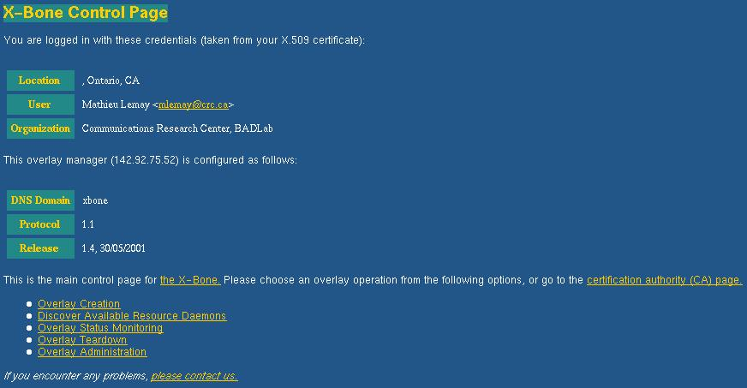
- Figure Showing the Control Page GUI

Once all authentication is done, you will be sent to the X-Bone Control Page. This page is the main screen from which you can access all of the X-Bone's functions.

There are 5 main options to choose from in that screen

1. Overlay Creation: This option will bring you to a page where you can create an overlay.
2. Discover Resource Daemons: This screen will show you the available computers that can be in the overlay.
3. Overlay Status Monitoring: This screen will give you the status of the different nodes belonging to an overlay as well as the tunnel configuration creating as the underlying layer.
- Overlay Teardown: This enables you to choose an overlay to delete.
- Overlay Administration: This will delete all overlays and tunnels.

Overlay Creation:

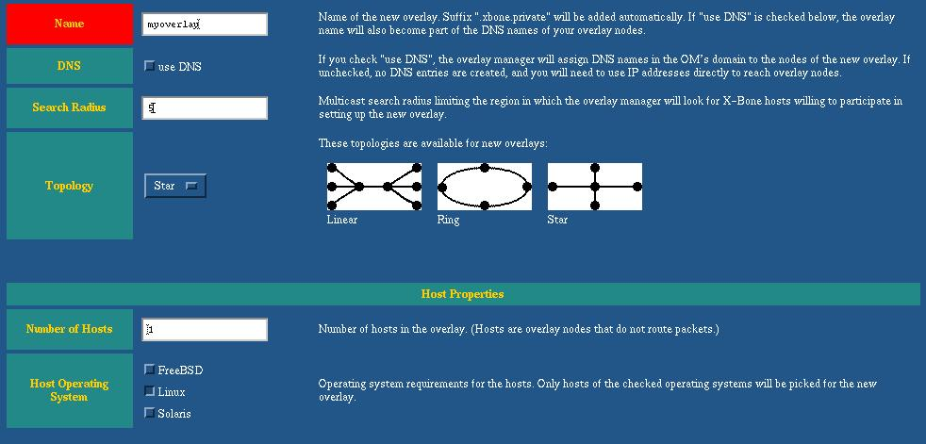

Picture of the overlay name and topology section.
Name: Here you enter the domain name that will be added to the xbone suffix, it can only contain alphanumeric characters.
Search Radius: This is the number of hops to search for X-Bone daemons.
Topology: Here you can choose between the different types of topology. If you choose the star topology, all hosts will connect to a router. If you choose line all hosts will connects to routers and routers will connect to other routers. If you choose Ring, only routers connect to other routers.

Picture of the host properties section.
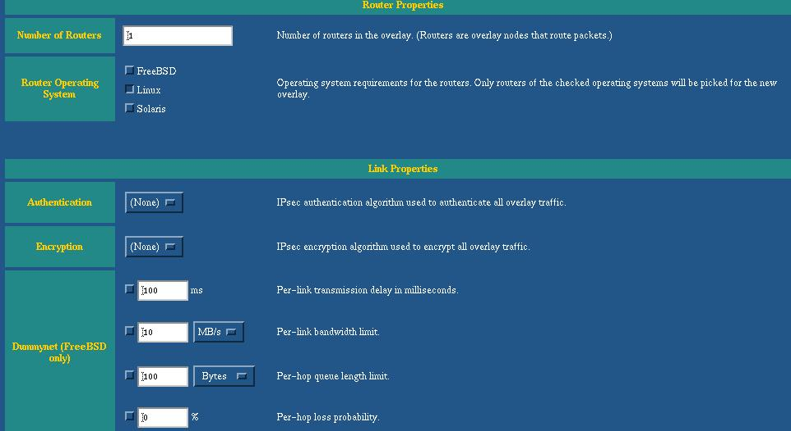

Picture of the router properties section.
Number of hosts: Here you enter the number of hosts that need to be part of that overlay.
Host Operating System: Make sure to select Linux as the OS.
Number of Routers: Here you enter the number of routers that need to be part of that overlay.
Router Operating System: Make sure to select Linux as the OS.

Picture of the link properties section.
Authentication: Select None here because IPSec is not yet implemented under Linux.
Encryption: Select None here because IPSec is not yet implemented under Linux.
DummyNet: This is supported under FreeBSD only so your settings won’t affect anything.

Discover Resources Daemons
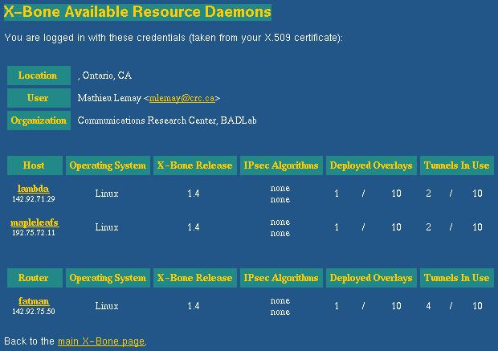

Picture of discovered resource daemons

This displays the computers found running the X-Bone Resource Daemon (RD) and tells you what role they can play on an overlay. Also, it shows the number of deployed overlays and how many tunnels are in use.
The Overlay Manager chooses automatically certain machine to form an overlay, the user have no control on that.

Overlay Status Monitoring

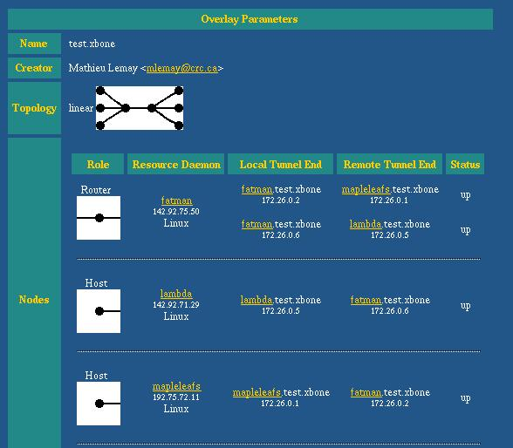

Picture of the test.xbone overlay status

This shows the IP addresses of the tunnels as well as the status of the daemon on the station. It also shows the overlay name and creator.

Overlay Teardown & Administration
These windows are simple. They are used to respectively delete either the selected overlay (Teardown) or all overlays (Administration).

Traffic Control Management

Overview
The X-Bone runs over many systems where no QoS implementation is available. In order to implement traffic control into X-Bone, we need to add different modules and to modify the current source code. Indeed, X-Bone works with three basic components that communicate with each other. The GUI communicates with the Overlay Manager and the Overlay Manager can communicate with the Resource Daemons. The module's role will be to pass on "tc" or "ip" commands to the various daemons running to the host machines.

Objective
The purpose of our traffic control implementation is to be able to split the bandwidth in any way between each connected host. Once this is done for each site, subclasses can be created to prioritize the audio packets coming from a specific port or address. We can limit the bandwidth coming from certain paths to accommodate the differences in the physical link capabilities. The priority levels for this traffic control are created using different classes.

Different classes used to control traffic on an ISABEL terminal.

Problems
Multiple problems were encountered while trying to implement the traffic control:
. We need to find what the application of traffic control on the LearnCanada project was before implementing it; how it would be used and what type of Quality of Service (QoS) should be used.
. The X-Bone need to do dynamically configured traffic controlled.
. The X-Bone doesn’t allow different bandwidth for different path and it was not useable under Linux because it uses special dummy net calls.
. It is impossible to include the traffic control functions under another X-Bone command API.
. It ‘s not yet known how to find the different interfaces that belongs to X-Bone.

Solutions
Traffic control can not yet be implemented. Presently, we are using differentiated services from the hardware named Xedia AP 100. The Xedia AP100 is a device that enables to manage the traffic based on the number of parameters, including the TOS bits. It is an ideal tool to enable true assessment of Differentiated Services at the network edge. Differentiated Services can potentially provide the needed QoS without the high network overhead associated with RSVP.

X-Bone Applications Notes

X-Bone is an overlay manager, which creates tunnels between different computers
There are three different topologies possible for tunnel configurations.
Bus Topology Star Topology Ring Topology
By comparing the above topologies with those of a multicast enabled network (below), we can see that for the same number of computers there will be less computing & network resources used when running the ISABEL application with multicast support. As each computer only needs to generate one stream of video and audio to the network to reach all other computers.
Multicast Data Streams

The use of X-Bone to create overlays will result in a less efficient topology than a multicast enabled one. For ISABEL networks using Flow Servers, both concepts can be combined to realize a VPN across the public infrastructure and multicast support within the private infrastructure as depicted in figure below

Combining VPN & Multicast Concepts

The X-Bone is not limited to overlay deployment, more than half of its source code is devoted to the creation of a secure system in which a server can automatically configure a host machine from a remote distant. This might be very useful for the operation and management the LearnCanada National Test Network because we can remotely implement different configuration for each site without fearing about any security flaw.

Also Perl modules can easily be created to follow the X-Bone protocol regarding action requested either for the overlay manager or the X-Bone Daemon. Examples of various uses of X-Bone might have if it was applied to remotely configure host computers are listed below.
. Traffic control implementation on the physical interface for each site (with different traffic regulation for each site instead of having the same traffic limits. This can be done even for a multicast session.).
. Remote host logging, file management, e-mail file sending (we could archive the logs from every sites and send them to a special e-mail account).
. Remote testing (instead of having to ask everyone to run a script you can implement a Perl module that requires every daemon with root authority to run certain commands and send results to an e-mail address, a file, or an FTP site.).

Currently X-Bone is only available for UNIX based systems and needs multicast for resource discovery. The IP addresses are allocated dynamically but once the overlay name is set we can just use the overlay DNS functions to ensure that it will always resolve to the right tunnel IP address. We must put the overlay manager’s IP address in the resolv.conf file and move all the machines out of the firewall.

(iii) Test Plans & Results

Once all the processes have been understood and implemented, we can setup some test-bed like followings:

The Original X-Bone Test bed

The basic setup consists of at least 3 machines with each doing different tasks in the overlay.
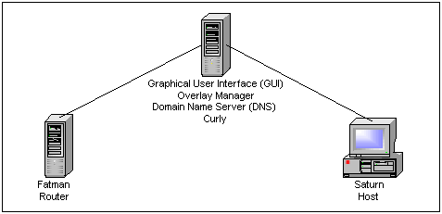

Figure of the computers used for the first X-Bone Test bed.

Curly acts as the Overlay Manager meaning it is the computer that controls the request for the creation of the tunnels as well as the overall overlay topology (Star, Bus, Ring). It also acts as the GUI for the Overlay Manager using Apache+SSL to do the authentication. Saturn acts like a normal host on the network and we will test the basic network functional over X-Bone from this computer. Fatman acts as a router and therefore is the central point of this star topology once the overlay is setup.
Once the overlay is laid the VPN will look as if that two computers are Peer to Peer. In this setup, the Overlay Manager is not part of the network except to provide DNS capabilities over the network.

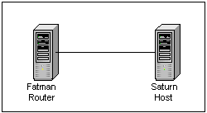

Figure of the created overlay
We took the measurements to see how the extra headers affect the performance. The difference is maximal 1Mbps for the path going through the tunnel, average is around 500Kbps. After running an ISABEL session under an X-Bone overlay we found that since it only requires around 2Mbps there is no noticeable performance loss.

The Advanced X-Bone Test bed

In this scheme, we test Isabel over X-Bone between Badlab, Virtual Classroom and OCDSB. The X-Bone was installed and run in all machines except kappa. We use Overlay Manager to create the overlay in star topology. The diagram below shows the network ‘s configuration.

Isabel test over X-Bone between Badlab, Virtual Classroom and OCDSB
- Curly is the Overlay Manager and the Router for the whole X-Bone network. All the X-Bone clients connect to curly by the point-to-point tunnel and curly routes the traffic among them.
- Lambda is the Isabel flowserver who acts as an application level multicast server. All machines send Isabel traffic to lambda, lambda merges the traffic together and send it back.
- Kappa is the master site who coordinates Isabel session. It connects to the flowserver by the regular interface (we want to keep this machine clean of X-Bone program).
- Other machines configured to be Interactive Terminal using virtual interface.
- Both tcpdump and iptraf launched on the flowserver to monitor the Isabel traffic through the tunnel interface.
We had Isabel session running on 5 sites. Everything worked fine. The quality of video and audio was not much different comparing with the one without X-Bone. As the bandwidth is not an issue, we didn’t notify the degradation of performance in our case. In fact, the X-Bone has never been implemented for the whole LearnCanada network nor used for the real event because:
. Most of LC site cannot support multicast
. Additional software or hardware would be needed to implement QoS
. LC project is not ready to sacrifice the performance for the security.

The traffic control test bed

In the current test, we use a Xedia AP 100 to properly define and manage the traffic at the edge according to Differentiated Service rules. AP100 uses Class-base-Queuing (CBQ) to provide advanced bandwidth management and traffic shaping. The Class-based Queuing test is setup like the schema below
Traffic control test bed

- AP 100 configured to manage the bandwidth and to classify the traffic by IP address and protocol type.
- Interwatch 95000 configured to generate the traffic on port 7B and to monitor the traffic on port 7A.
- Video server delivers the video streaming content at 1.5Mbps.
Without the AP 100, i.e. the 10Mbps Hub connects directly to Cat 5500, video streaming is stopped working when Interwatch injects 7.6 Mbps of best effort traffic. With AP 100, video streaming always works no matter how big the best effort traffic injected to the network.
By incorporating AP100 to X-Bone Overlay Network, we can have bandwidth management and the private encrypted in the shared network. To have bandwidth management for all LC sites, we need more than one AP 100.

(iv) Conclusion & Suggestion

The implementation of X-Bone is a very hard task. The instruction found on the Web is clearly not enough. We had to request for the supplement information, to compile the source code and to learn by ourselves. Several modules and programs are interdependent, one has to be installed after other. Every step must follow correctly and precisely. The authentication procedure is very implicit, Overlay Manager doesn’t give an appropriate error message.
The test Isabel over X-Bone gave a very good result, there was barely loss of performance by the extra overheads. Further more, there was improvement of behavior in the test of traffic control. Unfortunately we could not deploy and test X-Bone for the whole LearnCanada network. Hopefully, X-Bone people will take our suggestion in consideration by relaxing the requirement of multicast and by incorporating the traffic control in their new project called DynaBone.

Machine Configurations

. Curly:
DNS Name: curly.badlab.crc.ca
IP Address: 142.92.75.52/29
CPU: PII 350MHz
RAM: 125MB, ROM:8GB (Linux)
OS: RedHat Linux 7.1 Kernel 2.2.16-22 Glibc 6
. Saturn:
DNS Name: saturn.badlab.crc.ca
IP Address: 142.92.75.51/29
CPU: PIII 550MHz
RAM: 125MB, ROM:4GB (Linux)
OS: RedHat Linux 7.0 Kernel 2.2.16-22 Glibc 6
. Fatman:
DNS Name: fatman.badlab.crc.ca
IP Address: 142.92.75.50/29
CPU: PIII 500MHz
RAM: 256MB, ROM: 4GB (Linux)
. Senator:
DNS Name: senators.virtualclassroom.crc.ca
IP Address: 192.75.72.12/24
CPU: PIII 933MHz
RAM: 256MB
OS: RedHat Linux 7.0 Kernel 2.2.16-22
. Lambda:
DNS Name: lambda.badlab.crc.ca
IP Address: 142.92.71.29/24
CPU: PIII 750MHz
RAM: 256MB
OS: RedHat Linux 7.0 Kernel 2.2.16-22
. Omnicron:
DNS Name: omnicron.badlab.crc.ca
IP Address: 142.92.76.3/29
CPU: PIII 800MHz
RAM: 256MB
OS: RedHat Linux 7.0 Kernel 2.2.16-22
. OCBSD1:
DNS Name: ocdsb1.badlab.crc.ca
IP Address: 142.92.141.10/24
CPU: PIII 933MHz
RAM: 256MB
OS: RedHat Linux 7.0 Kernel 2.2.16-22
Example OM and GUI config files

Overlay Manager (XB_Defs.pm)
######### Parts of XB_Defs.pm #########
############################################################
# The following are used only by xb-overlay-manager
# They are provided here because
# - xb-overlay-manager has no config file
# - this is the place for changeable constants
############################################################

$XB_Defs::XBONE_OVERLAY_MANAGER = # Hostname used by the OM to
"142.92.75.52"; # identify itself in heartbeats

Resolvable hostname or IP address of overlay manager.

$XB_Defs::CA_EMAIL = # email address of the CA that signs
"X-BoneAdministrator ".# certificates for this xbone installation
"<mlemay\@crc.ca>";

E-mail address for the CA used when signing the "more secure way" using sign-cert.pl

############################################################
# The following are used only by nearly everybody :-)
############################################################

$XB_Defs::XBONE_NET = # The domain name associated with this
"xbone"; # particularicular X-Bone overlay network.

Change this to the desired suffix. Remember that the domain name (named files must be changed if you change this)

$XB_Defs::DNS_SERVER = # Primary X-Bone DNS name server
"142.92.75.52";

$XB_Defs::DNS_SERVER_SECONDARY = # Secondary X-Bone DNS server
"";

# IPv6 peek: define mcast address
$XB_Defs::MCAST_ADDR = # Multicast address used by XBONE
"224.192.0.1";

$XB_Defs::MAX_MCAST_RADIUS = 16; # The largest radius that should be used

###### END#####

X-Bone Daemon Configuration
This is the X-Bone_daemon.conf file found in the etc directory. When editing this file please be careful not to remove a \.

XboneNode \
IPaddr=142.92.75.51 \
This is the ip address of this node.
MaxTunnelCount=100 \
This is the maximum number of tunnels.
Authentication=none \
IPversion=IPv4 \
Encryption=none \
TunnelCount=0 \
This is the location of the provided key file.
SSLkey=/etc/xbone/cert/saturn.badlab.crc.ca.key.pem \
OverlayManagers={ curly.badlab.crc.ca } \
OverlayCount=0 \
Dummynet=no \
This is the name that will appear on the overlay manager screen.
ID=saturn.dsar.crc.ca \
This is the role of the node.
Class=host \
MaxOverlayCount=3 \
This is the location of the provided certificate file.
SSLcert=/etc/xbone/cert/saturn.badlab.crc.ca.cert.pem

Access control List :
XboneAclList \
OverlayCount=0 \
MaxTunnelCount=100 \
This is the regular expression that must match the e-mail of the certificate to make it valid.
UserAuth=\S* \
MaxOverlayCount=1 \
This is the name that will be given to the station on the overlay manager (if this user logs on)
ID=saturn.dsar.crc.ca \
TunnelCount=0 \
This is the type of user access for this ACL. (deploy can create overlay, manage can only view the status)
AccessLevel=deploy

Traffic Control Management

Overview
Traffic control can be done using 2 methods Integrated Services (Intserv) and Differentiated Services (Diffserv). This implementation will start by using the Intserv quality of service (QoS) methods. The Intserv is divided into three processes. First is the Queuing discipline, which's role is to create different queues to put packets in. It also is the one that acts as the Packet Scheduler sending the right packet from the queue. After establishing the queuing discipline, we have to create classes. The third and last element is the classifier (filter) that will treat packets and will send them to their corresponding classes.

Class Base Queuing (CBQ)
Class based queuing is used to limit the bandwidth of certain types of packets called classes. These classes are created in a hierarchy were you can give higher priority to some classes if you want them to go through heavy traffic. This may be useful if you're a consultant and you want to work on a remote machine using Secure SHell (SSH) but this machine is so busy (Web server, ftp etc.) that you have problems getting the packets through, you can specify a class for SSH and give it higher priority so your packets can go through easily.

Stockness Fair Queuing (SFQ)
SFQ requires little CPU and memory but is not a fair algorithm. In SFQ data packets with common parameters are considered from the same "conversation" and it sends one packet from each associated queues. It is used to limits the bandwidth abuse for a special queue.

Token Bucket Filter (TBF)
TBF is a lot like SFQ but it requires a lot of CPU, it makes sure that no packet can go higher than the limited bandwidth.

Differentiated Services Mark (DSMARK)
DSMARK uses the TOS field in the packet header to set a priority. It is not an integrated service

NetFilter and Iptables
Netfilter and Iptables go together because Iptables uses the kernel’s netfilter functions to place packets into the different tables (chains).

Kernel Requirements
IP: Advanced router = Y,m
IP: policy routing = Y,m
IP: use netfilter MARK value as routing key = Y,m
IP: Network packet Filtering (replaces IP chains) = Y,m
QoS: use QoS and/or Faire Queuing. = Y
QoS: CBQ or otheres =Y,m
QoS: Ingress = Y,m
QoS: QoS Support = Y
QoS: All classifiers (TC, U32, etc..)
NetFilter = Mangle MARK ip packets (Y) and put the rest as modules

Perl Modules modified
GUI-Overlay-Manager API
(File: xb-overlay-manager)
Syntax for API:
Xbone Version = 1.0
Xbone Control Command= TrafficControl Transaction=Create
Xbone Overlay Name= overlay.xbone.net
XboneTraffic TrafficElement= qdisc \
Action= Add \
ElementParams Type=cbq \
Xbone Version = 1.0
Xbone Control Command= TrafficControl Transaction=Request
Xbone Overlay Name= overlay.xbone.net
XboneTraffic TrafficElement= qdisc \
Action= Add \
ElementParams Type=cbq \

Perl Modules added
XB_Traffic.pm

Perl CGI-Script

