Appendix A

LearnCanada National Test Network (LC NTN)

The following section will the typical list of equipment required at participating sites, and it will breakdown the cost of the required equipment. This appendix is divided into three sections covering (1) Typical list of equipment required at each participating sites, (2) The cost of the required equipment, (3) The LC NTN site description.

(1) Typical List of Equipment:

To run a successful ISABEL session, each site must be equipped with certain equipment and software. The following section lists the equipment/software required by each participating site. Equipment/software list is divided into ISABEL workstation, Audio/Visual (A/V) equipment, Software.

ISABEL Workstation:

Two PCs running Linux Redhat was the requirement for each LearnCanada site. One of the two PCs was dedicated for the video collaboration, ie; ISABEL video, audio, data, etc. The second was dedicated as a display or control station, video annotation client, etc.

Minimum requirement:

- Intel Pentium III 866 MHz processor
- 256 MB RAM
- Video Buffer Card (capable of running 1024x768)
- Sound card
- Supported by Advanced Linux Sound Architecture
- Note: ALSA drivers are designed to and can be configured to emulate full duplex on a sound card, which cannot handle full-duplex via hardware. ALSA emulates full duplex via software. Therefore, OSS will still run under ISABEL, however, software is optimized for ALSA.
- 10/100/1000 Ethernet card
- Video Capture/Tuner card
- Card must use BT848 or BT878 chipset.
- USB cameras can also be used, however, the camera must be supported by video4linux.

Audio/Visual Equipment:

- Microphone(s)
- Camera(s)
- Audio Mixing Board
- Video Mixing/Switching Board (If multiple video inputs are used)
- Projector
- Distribution Amplifier

Software:

- Linux Redhat 7.2
- ISABEL Application version 4.5-0
- ISABEL Teleconference template version 4.5
- ISABEL Teleclass template version 4.5
- OS capable of running Internet Explorer and Quicktime video.

(2) Equipment cost breakdown:

- PC: $3000
- A/V Equipment:
- Audio: $2000
- Video: $2000
- Software: $200

The cost break down is an approximate cost during the start of the project.

(3) LC NTN network configuration and setup:

LearnCanada National Test Network diagram:

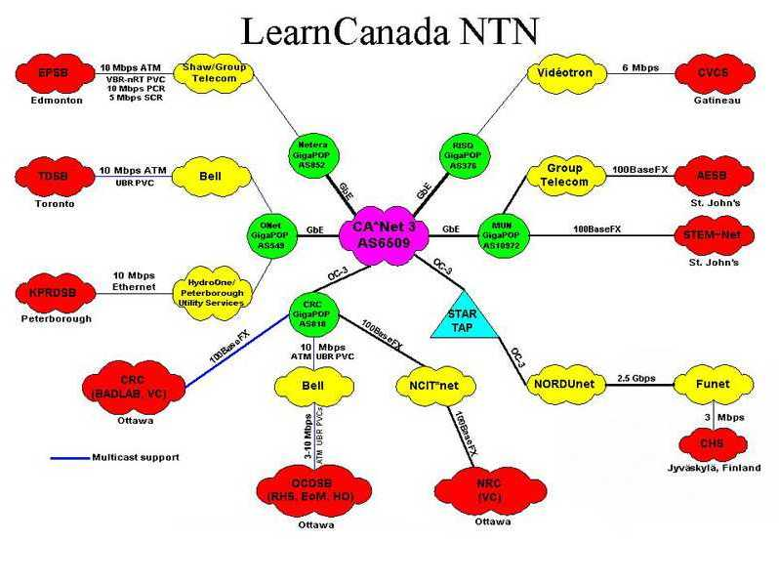

Individual LearnCanada site description:

The LearnCanada National Test Network (NTN) was made up of school boards across Canada and several federal Institutions. School boards include from Newfoundland, Avalon East School Board (AESB), from Quebec, Conseil Commission Scolaire au Coeur-des-Valees (CSCV), from Ottawa, Ottawa Carleton District School Board, from Toronto, Toronto District School Board, from Peterborough, Karwartha Pine Ridge District School Board (KPRDSB), and from Edmonton, Edmonton Public School Board (EPSB). Federal Institutions include the Communications Research Centre Canada (CRC) and the National Research Council (NRC).

The following sections will outline the equipment and network configuration of each school board, and from CRC and NRC.

(i) Avalon East School Board (AESB):

Avalon East School board connects directly to the MUN GigaPOP (AS10972). The connection is a 100 Mbps Vlan from the GigaPOP router to Holy Heart of Mary High school. Connection was provided by Group Telecom. Multicasting was not possible.

Network Diagram

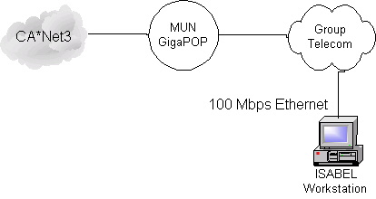

Computers

Isabel Workstation

- Intel Pentium III 866 Processor
- Dual slot motherboard (Brand unknown)
- 256 MB SDRAM 133 MHz
- 20 GB Hard Drive
- CDROM Drive
- ATI All in wonder Pro AGP 32 MB Video card
- 3Com 3C905TX 10/100 PCI NIC
- SoundBlaster Live! 128 Sound card
- Intel Smart Video Recorder III PCI capture card

Audio / Video Equipment

Video Equipment

- Sony EVI-D30 Camera

Audio Equipment

- Direct microphone input and speaker out.

Network Information

Unicast IP Addresses

AESB was given 198.165.161.82 as the workstation address.

(ii) CSCV:

Conseil Commission Scolaire au Coeur-des-Valees connection to CA*Net 3 is through the RISQ GigaPOP (AS376 ) located in Montreal. The school was connected with a 6 Mbps connection, which was provided by VideoTron. Multicasting was not possible.

Network Diagram

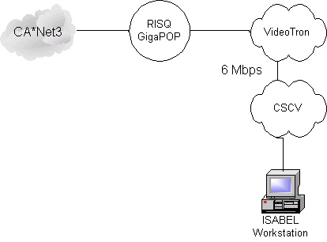

Computers

Isabel Workstation

- Intel Pentium III 800 MHz dual Processor
- Tyan Tiger 200 (S2505) Dual slot motherboard
- 512 MB SDRAM 133 MHz
- 20 GB 7200 rpm Hard Drive
- CD-ROM Drive
- AVERMEDIA TV/FM 98 Stereo BT-848 chipset
- Sound Blaster Live Value
- Integrated Video and 10/100 NIC Cards.

Display Station

- Intel Pentium III 800 MHz Processor
- 256 MB SDRAM 133 MHz
- Tyan Tiger 200 (S2505) Dual slot motherboard
- 20 GB 7200 rpm Hard Drive
- CD-ROM Drive
- AVERMEDIA TV/FM 98 Stereo BT-848 chipset
- Sound Blaster Live Value
- Integrated Video and 10/100 NIC Cards

Audio/Video Equipment

Video/Visual Equipment

- Sony EVI-D30 Teleconference camera
- JVC SXM320U Camcorder
- JVC JX-S700 A/V Selector Switch
- Philips Hopper SV20I Projector
- Projector screen 84” X 84”
- JVC HR-VP780U VHS VCR

Audio Equipment

- Extron Electronics P/2 DA2 Plus Distribution Amplifier
- QSC model USA 400 Audio Amplifier
- 4 Electro-Voice SX-80 Speakers
- 2 Unidirectional Microphones AKG D-72
- SHURE THD-CC Wireless microphone
- Mackie 1202V Mixer

Network Information

Unicast IP Addresses

CSCV was given 206.167.152.0/24. 206.167.152.1 was reserved as the gateway address. Workstation was given .2.

(iii) Edmonton Public School Board (EPSB)

Edmonton Public School Board connected J. Percy Page High School to CA*Net 3 for the LearnCanada Project. A 10 Mbps connection was originally provided by Shaw Communications, later taken over by Group Telecom, to the Netera GigaPOP (AS852). Multicast was not enabled. A planned upgrade from 10 Mbps to 100 Mbps did not happen as Group Telecom did not think the it was feasible.

Network Diagram

Computers

Isabel Workstation
- Intel Pentium III 800 MHz Processor
- Dual slot motherboard (Brand unknown)
- 256 MB SDRAM 133 MHz
- Video Card (known)
- Hard Drive (SCSI - size and brand unknown)
- SoundBlaster Live! Sound card
- 3Com 3C905TX-B 10/100 PCI NIC
- VideoLogic Captivator - video capture card.

Audio / Video Equipment

Video Equipment

- Sony Digital Video Cameras (x2)
- Panasonic Camcorder
- Canon Digital still camera
- NEC Projectors with VGA inputs (x2)
- Standard Wired Microphones

Audio Equipment

- Unknown

Network Information

Unicast IP Address

JPP was given a subnet of address from 206.75.91.192. Netmask was 255.255.248. Reserved IP of 206.75.91.193 was given to the gateway router address.

(iv) Kawartha Pine Ridge District School Board (KPRDSB)

Karwartha Pine Ridge District School Board connected one school to CA*Net 3 for the Learn Canada Project. Peterborough Collegiate and Vocational Institute reached CA*Net 3 via HydroOne to the Onet GigaPOP (AS549). The connection was an extended 10 Mbps Vlan from ONet. Multicast was not enabled.

Network Diagram

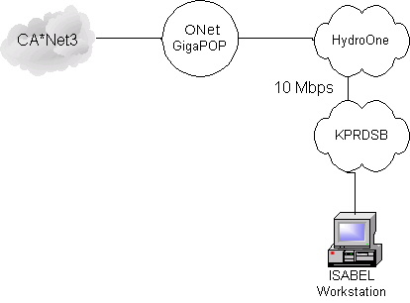

Computers

Isabel Workstation

- Intel Pentium III 933 MHz Dual processor
- ASUS CUV4X-D Dual slot motherboard
- 256 MB SDRAM 133 MHz
- Forse TNT-2 32 MB AGP Video card
- Quantum 30 GB 7200 rpm Hard Drive (Quantity = 2)
- Pioneer 16x DVD IDE
- SoundBlaster Live value
- 3Com 3C905TX-C 10/100 PCI NIC
- WINTV GO 125 Video Capture Card (Model 700)

Display Station

- Intel Pentium III 933 MHz Dual processor
- ASUS CUV4X-D Dual slot motherboard
- 256 MB SDRAM 133 MHz
- Forse TNT-2 32 MB AGP Video card
- Quantum 30 GB 7200 rpm Hard Drive
- Pioneer 16x DVD IDE
- SoundBlaster Live value
- 3Com 3C905TX-C 10/100 PCI NIC
- WINTV GO 125 video Capture Card (Model 700)

Audio / Video Equipment

Video Equipment

- Hand held camcorder.

Audio Equipment

- Unknown

Network Information

Unicast IP Addresses

ONet provided KPRDSB with the following address space, 206.248.104.0/24. Reserved IP address of 206.248.104.1 was given to the gateway interface. KPRDSB technician assign .4 for the ISABEL workstation and .5 for the display station.

(v) Ottawa Carleton District School Board (OCDSB)

Two schools (Earl of March High School and Rideau High school) and the schools board office is connected to CA*Net 3 for the LearnCanada Project. Connection was provided by Bell, which connects to the CRC GigaPOP. The two schools and the head quarters connected to a Cisco 5500 at the Bell CO. From the Bell CO, a 10 Mbps UBR ATM PVC circuit which terminated at the CRC GigaPOP. Running routed PDU.

The connection to the board office was a 100 Mbps full duplex ethernet connection, and to the two schools were connected with a 10 Mbps half duplex connection. Multicasting was enabled to all OCDSB sites.

IP addresses used for the school was part of CRC's address space. 142.92.10.0/24 was provided to OCDSB for the purpose of LearnCanada.

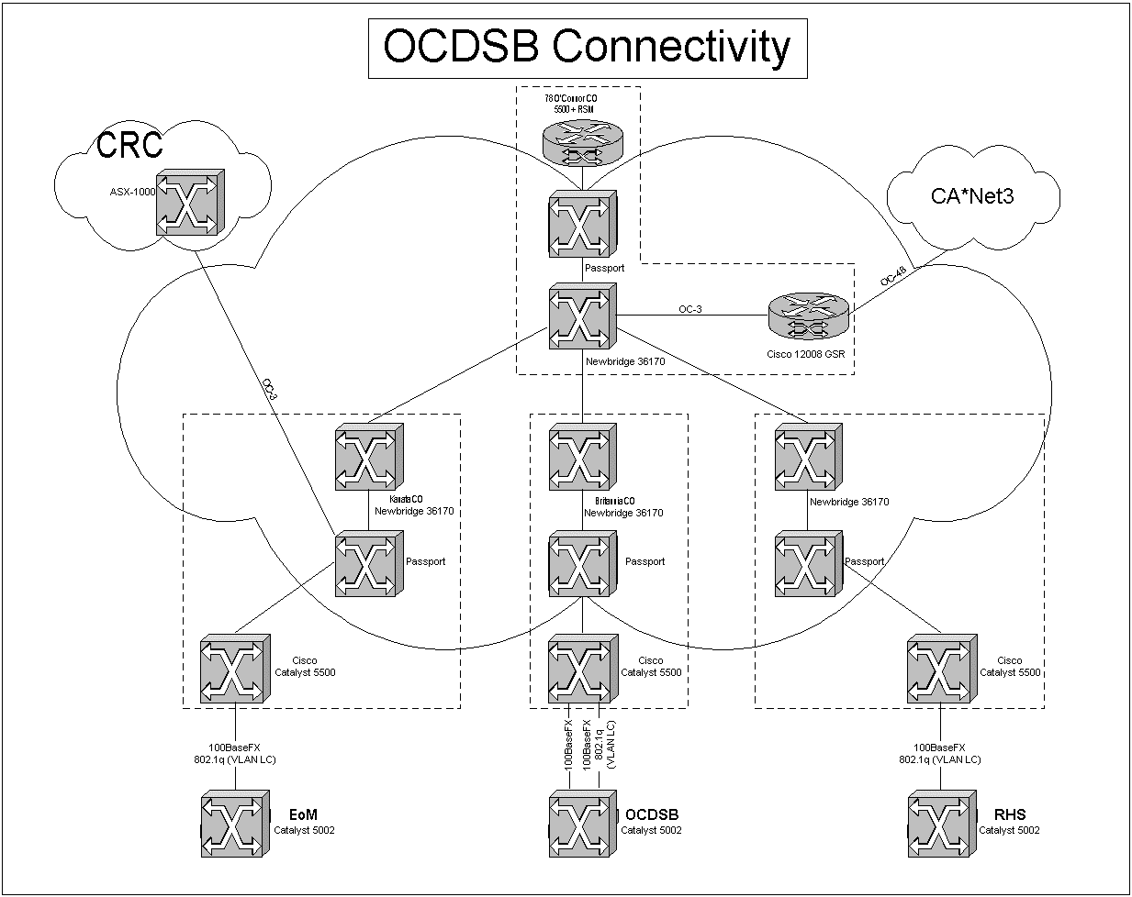

Computers

Isabel Workstation OCDSB HQ, Rideau and EofM

- Intel Pentium III 933 MHz Processor
- Tyan Tiger 133 Dual slot motherboard
- 256 MB SDRAM 133 MHz
- Matrox 16 MB video card
- Matrox 20 GB 7200 rpm Hard Drive
- CDROM IDE
- Creative Ensoniq 1371 sound card
- Diamond DTV2000 Video capture card
- 3Com 3C905TX-C 10/100 PCI NIC

Audio / Visual Equipment

Video Equipment

- Sony EVI-D30 Camera
- Optoma 610H (1100 Lumens) Projector

Audio Equipment

- Behringer MX2400A Eurorack (8channel inputs)
- Rec Event Project Studio PS-6 Speakers
- Audio-Technica ATM41HE Hypercard Microphones

Network Information

Unicast IP Addresses

142.92.141.10 -> Isabel workstation OCDSB HQ
142.92.141.160 Isabel workstation Rideau HS
142.92.141.30 ->Isabel workstation EofM HS

(vi) Toronto District School Board (TDSB)

Toronto District School Board connected two schools, Monarch Park High school and . A 10 Mbps ATM circuit was provided by Bell. TDSB reached CA*Net 3 via the ONet GigaPOP (AS549) located in Toronto. Multicast was enabled.

Network Diagram

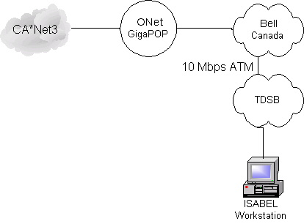

Computers

Isabel Workstation

- P3-500 MHz
- The rest is unknown
- Display Workstation
- No display workstation.
- Audio / visual Equipment

Audio/Video Equipment

Video Equipment

- Sony camera

Audio Equipment

- Behringer EuroRack MX1604 Audio Mixer

Network Information

Unicast IP Addresses

205.211.94.3 -> Isabel Workstation

(vii) CRC BADLAB

Network Diagram

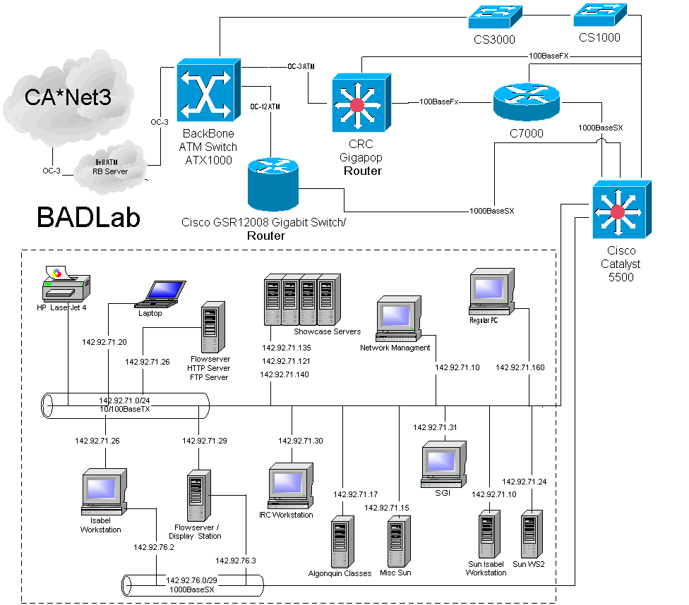

Computers

Isabel Workstation

- Intel Pentium Dual 866 MHz Processor
- ASUS P3C-D Dual slot motherboard
- 256 MB RIMM 400 MHz
- Diamond Viper II Z200 32 MB AGP Video Card. S3 Savage2000 Chipset
- Pioneer DVD IDE
- Matrox 20 GB 7200 rpm 9 MS 2 MB Hard drive (times 2)
- 3Com 3C905TX-B 10/100 PCI NIC
- 3Com 3C985-B Gigabit Ethernet NIC
- Creative Ensoniq 1371 sound card
- Diamond DTV2000 Video capture card

Isabel Workstation / Isabel Flowserver

- Intel Pentium Dual 800 MHz Processor
- ASUS P3C-D Dual slot motherboard
- 256 MB RIMM 400 MHz
- Diamond Viper II Z200 32 MB AGP Video Card. S3 Savage 2000 Chipset
- Pioneer DVD IDE
- Matrox 40 GB 7200 rpm 9 MS 2 MB Hard drive (times 2)
- 3Com 3C905TX-B 10/100 PCI NIC
- 3Com 3C985-B Gigabit Ethernet NIC
- Creative Ensoniq 1371 sound card
- Diamond DTV2000 Video capture card

Flowserver

- Intel Pentium 750 MHz Processor
- ASUS P3C-2000 Single slot motherboard
- 256 MB SDRAM 133 MHz
- Diamond Viper V770 32 MB AGP Video Card. Nvidia TNT-2 Chipset.
- Hitachi DVD IDE
- Quantum 20 GB 7200 rpm Hard drive
- 3Com 3C905TX-B 10/100 PCI NIC
- SoundBlaster AWE32 ISA sound card

Flowserver / FTP Server / HTTP Server

- Intel Pentium III 600 MHz
- ASUS P2B-D Dual slot motherboard
- 256 MB SDRAM 133 MHz
- ATI Xpert 128 Rage 8 MB AGP video card
- Matrox 20 GB 7200 rpm Hard Drive
- Hitachi DVD IDE
- SoundBlaster AWE 32 ISA sound card
- 3Com 3C905TX-B 10/100 PCI NIC
- Diamond DTV2000 Video Capture Card

Audio / Video Equipment

Video Equipment

- Canon VC-C1
- Canon VC-C1 MK-II
- Sony DRC PC100 Digital Camcorder
- Sony DCR-TRV110 Digital 8 Camcorder
- JVC TK-128OV Video Camera
- Elmo visual presenter EV-500 AR
- JVC Hi-Fi VCR
- NEC PlasmaSync PX-50XMIA MP501
- BARCO Data 2100 LC projector
- Extron Video Switcher
- AD Chroma Quad video switcher
- JVC Y/C digital Effects Generator KM-D600

Audio Equipment

- Mackie CR1604-VLZ 16 Channel Mic/Line Mixer
- Shure Uni-directional wired mic (x2)
- Shure LX Uni-directional wireless mic
- Inkel PA2000 Public Address Amplifier
- Axiom millennia speakers

Network Information

Unicast IP Addresses

142.92.76.2 -> Isabel Workstation
142.92.76.3 -> Isabel Workstation/Isabel Flowserver
142.92.71.29 -> Flowserver
142.92.71.12 -> Flowserver/ FTP Server / HTTP Server

(viii) CRC Virtualclassroom

Computers

Flowserver

- Intel Pentium III 933 MHz processor
- ASUS CUV4X-C Single slot motherboard
- 256 MB SDRAM 133 MHz
- Forse TNT-2 32 MB AGP Video card
- Quantum 30 GB 7200 rpm Hard Drive
- Pioneer 16x DVD IDE
- SoundBlaster Live value
- 3Com 3C905TX-C 10/100 PCI NIC

Isabel Workstation

- Intel Pentium III 933 MHz Processor
- ASUS CUV4X-C Single slot motherboard
- 256 MB SDRAM 133 MHz
- Force TNT-2 32 MB AGP Video card
- Quantum 30 GB 7200 rpm Hard Drive
- Pioneer 16x DVD IDE
- SoundBlaster Live! value
- 3Com 3C905TX-C 10/100 PCI NIC
- Diamond DTV2000 Video Capture Card
Audio / visual Equipment

Video Equipment

- Kramer VP-23 Switcher
- Canon VC-C3 Video Camera (x2)
- MiniView KVM Switcher
- NEC Multisync MT1040 Projector
- NEC PlasmaSync 50 MP1 (x2)

Audio equipment

- Yamaha AX592 Amplifier
- Shure Wireless microphones (x5)
- SoundCraft Spirit Folio Sound mixer

Network Information

Unicast IP Addresses

192.75.72.11 -> Flowserver
192.75.72.12 -> Isabel Workstation

(ix) NRC Virtual Classroom

The NRC is connected through NCIT-Net (using a 100 Mbps connection) and through the CRC GigaPOP. There is something between NCIT-Net and NRC than limits the bandwidth to 10 Mbps.

Computers

Isabel Workstation

- Intel Pentium III 733 MHz Processor
- Dell OptiPlex GX110
- 256 MB SDRAM
- 3Dfx Voodoo 3 16 MB Video Card (Disabled on board video card)
- 20 GB Hard drive
- DVD Drive
- Creative Ensoniq 1371 Sound Card
- Hauppauge WinTV GO (Model 700) Video Capture card
- On board Ethernet Card

Audio / Visual Equipment

Video Equipment

- Canon Handycam video camera.

Audio Equipment

- PC speakers
- Canon Handycam video camera microphone

Network Information

Unicast IP Addresses

142.92.133.13 -> Isabel Workstation

